Name: Class:
Introduction
Due to its high polarity, water is an excellent solvent. This function is especially important in our bodies. Many nutrients need to be dissolved in the water in our blood so that they can be transported throughout the body. Water’s capacity for hydrogen bonding contributes greatly to its solvent properties.

No. | Question | Answer
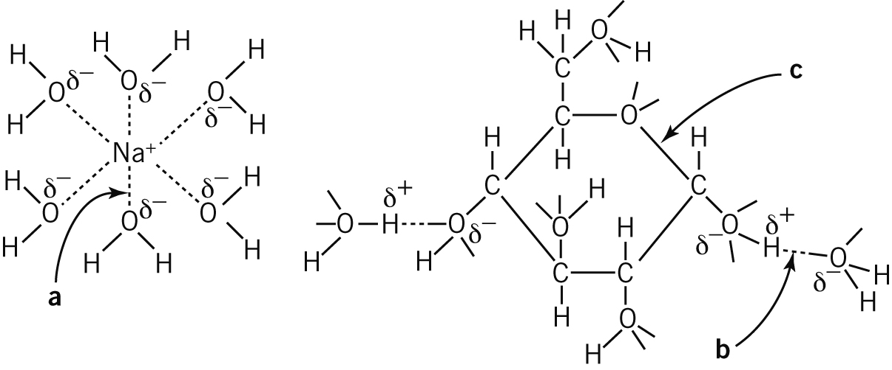
These diagrams show a sodium ion and a glucose molecule dissolved in water. Name the types of bonds indicated.

 | Why is glucose (C₆H₁₂O₆) more soluble in water than hexanol (C₆H₁₃OH) is, even though both molecules contain the same number of carbon atoms?
 | What are three substances that are transported in dissolved form in our blood?
 | Both water and ammonia can from hydrogen bonds, yet ammonia’s boiling point is much lower than water’s boiling point. Explain.
 | Water’s solvent capacity is also exhibited in seawater, which contains many dissolved substances. Name three ions that you would expect to find in seawater.
 | There are 1.35 × 10⁹ km³ of seawater in the world. Assuming the average density of seawater is close to that of pure water (1.00 g mL^{–1}), calculate the mass of bromide ions present in the world’s seawater if its concentration is 67 ppm of seawater. (1 km³ = 10¹² L)
Gases are generally less soluble than many ionic compounds in water. The table below shows some solubility data for four gases.

Gas | Formula | Solubility (g/100g) at 0°C | Solubility (g/100g) at 20°C | Solubility (g/100g) at 40°C
Ammonia | NH₃ | 90 | 53 | 31
Hydrogen chloride | HCl | 82 | 72 | 63
Oxygen | O₂ | 0.007 | 0.004 | 0.003
Nitrogen | N₂ | 0.003 | 0.002 | 0.001

No. | Question | Answer
 | What is the solubility trend as the temperature increases?
 | Propose a reason for this trend.
 | Divide the gases into two groups: polar and non-polar.
 | How does polarity affect solubility?
 | What types of bonds can each of the four gases form with water?
 | Propose an explanation for why at 0ºC ammonia is more soluble in water than hydrogen chloride, which in turn is more soluble than oxygen.
 | Which gas would you expect to be totally insoluble at 60°C?
 | How would the composition of freshly boiled tap water be different to that of cold tap water?
Carbon monoxide (CO) is 1.5 times more soluble than nitrogen at 20°C.
a How much CO could dissolve in 75 mL of water at 20°C?
b Why would CO be a more soluble gas than N₂?

 | Industrial plants releasing hot water into waterways like lakes and streams cause thermal pollution. How can this cause the death of marine animals?

